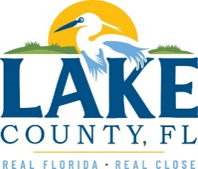
Office of Procurement Services
P.O. Box 7800 • 315 W. Main St., Suite 416 • Tavares, FL 32778
SOLICTATION: Mosquito Management Insecticide Chemicals 08/03/2023

Vendors are responsible for the receipt and acknowledgement of all addenda to a solicitation. Confirm acknowledgement by including an electronically completed copy of this addendum with submittal. Failure to acknowledge each addendum may prevent the submittal from being considered for award.
THIS ADDENDUM DOES NOT CHANGE THE DATE FOR RECEIPT OF PROPOSALS.
QUESTIONS/RESPONSES
Q1. There are only two spaces to add additional products on the pricing sheet. Is there any way to add more or are we capped at the two?
R1. Vendors may submit additional alternative products as an attachment to the pricing sheet with documentation substantiating the alternative as an equal product.
Q2. I just wanted to confirm that the ULV Oil listed isn’t any brand in particular. I assumed any ULV oil brand would do since I didn’t see a name but wanted to make sure.
R2. That is correct. The County has used different brands (BVA, Calpar). Note, they are all a mineral oil with the same viscosity.
ADDITIONAL INFORMATION
N/A

ACKNOWLEDGEMENT

Firm Name: Click or tap here to enter text.
I hereby certify that my electronic signature has the same legal effect as if made under oath; that I am an authorized representative of this vendor and/or empowered to execute this submittal on behalf of the vendor.
Signature of Legal Representative Submitting this Bid: Click or tap here to enter text.
Date: Click or tap to enter a date.
Print Name: Click or tap here to enter text.
Title: Click or tap here to enter text.
Primary E-mail Address: Click or tap here to enter text.
Secondary E-mail Address: Click or tap here to enter text.

