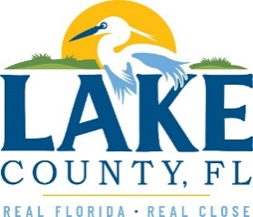
Office of Procurement Services
P.O. Box 7800 • 315 W. Main St., Suite 441 • Tavares, FL 32778
NOTICE OF INTENT TO SOLE SOURCE

PUBLIC NOTICE
This information informs the public and supplier community Lake County intends to enter into a non-competitive agreement to purchase a product/service as research indicates it is available from no other source.
If a qualified supplier can provide the same type of product/service, submit a statement of qualifications, product information and capabilities to the Point of Contact (Section 4.0) by 3:00 P.M. Eastern on Tuesday, June 27th, 2023. Submittals received after this specified time and date will not be considered. Any responses received shall be considered solely for determining whether bona fide competition exists.
- PRODUCT/SERVICE
Provide annual quantitative fit and bench flow testing and as needed repairs for MSA brand, self-contained breathing apparatus (SCBA) as required by the National Fire Protection Association (NFPA).
3.0 PROVIDER INFORMATION
Ten-8 Fire & Safety, LLC is the only known provider offering the described in its entirety without voiding manufacturer’s warranty.

POINT OF CONTACT
Gretchen Bechtel, Contracting Officer II
E-mail: gretchen.bechtel@lakecountyfl.gov

[The remainder of this page intentionally left blank]

