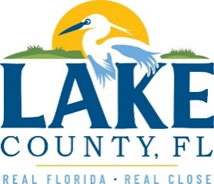
Office of Procurement Services
P.O. Box 7800 • 315 W. Main St., Suite 416 • Tavares, FL 32778
SOLICTATION: Actuary Study for Property, General Liability, and Workers’
Compensation Program 05/22/2023

Vendors are responsible for the receipt and acknowledgement of all addenda to a solicitation. Confirm acknowledgement by including an electronically completed copy of this addendum with submittal. Failure to acknowledge each addendum may prevent the submittal from being considered for award.
THIS ADDENDUM DOES NOT CHANGE THE DATE FOR RECEIPT OF PROPOSALS.
QUESTIONS/RESPONSES
Q1. Who served as the incumbent actuary?
R1. Glicksman Consulting, LLC
Q2. Was the County satisfied with the services?
R.2 Yes.
Q3. What fees were charged for the last three (3) years?
R3. 2020-2021 - $2,000.00
2021-2022 - $2,000.00
2022-2023 - $2,100.00
Q4. Were in person conferences held with the actuary?
R4. Initially there was an in-person meeting, subsequent years, no.
Q5. Were remote meetings held with the actuary?
R5. No.
ADDITIONAL INFORMATION

ACKNOWLEDGEMENT

Firm Name: Click or tap here to enter text.
I hereby certify that my electronic signature has the same legal effect as if made under oath; that I am an authorized representative of this vendor and/or empowered to execute this submittal on behalf of the vendor.
Signature of Legal Representative Submitting this Bid: Click or tap here to enter text.
Date: Click or tap to enter a date.
Print Name: Click or tap here to enter text.
Title: Click or tap here to enter text.
Primary E-mail Address: Click or tap here to enter text.
Secondary E-mail Address: Click or tap here to enter text.

