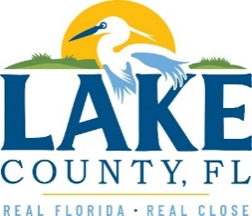
Office of Procurement Services
P.O. Box 7800 • 315 W. Main St., Suite 441 • Tavares, FL 32778
NOTICE OF INTENT TO SOLE SOURCE

PUBLIC NOTICE
This information informs the public and supplier community Lake County intends to enter into a non-competitive agreement to purchase a product/service as research indicates it is available from no other source.
If a qualified supplier can provide the same type of product/service, submit a statement of qualifications, product information and capabilities to the Point of Contact (Section 4.0) by 3:00 P.M. Eastern on Monday, January 30th, 2023. Submittals received after this specified time and date will not be considered. Any responses received shall be considered solely for determining whether bona fide competition exists.
- PRODUCT/SERVICE – GIS MAPPING, ANALYSIS, & DEVELOPMENT OF DATA DASHBOARDS
Urban SDK is a proprietary data analysis, visualization, and aggregation platform, unlike any solution on the market. Its system enables organizations to stream all data sources on a single platform, along with premium data provided by the contractor at no additional cost to the client. The data is displayed on dynamic dashboards, geospatial maps, and can also be downloaded in CSV form. In addition, all data sets provided in the Urban SDK Platform have automated federal performance measures associated that assist in the reporting requirements that must be met by an MPO. Urban SDK Platform is the only solution on the market to provide near real time data sets, Automated Performance Measures, GIS Visualization, Custom Dash boarding, Geospatial Data Management, and Data Share ability Features. Urban SDK updates performance measures based on client needs and then delivers the resulting updates free of charge to all existing clients, with enhancements occurring every two weeks.
3.0 PROVIDER INFORMATION
Urban SDK, Inc. is the only known provider offering the described in its entirety.

POINT OF CONTACT
Amy Munday, Contracting Officer
E-mail: Amy.Munday@LakeCountyFL.gov

[The remainder of this page intentionally left blank]

