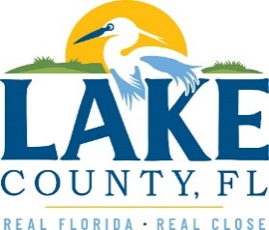
Office of Procurement Services
P.O. Box 7800 • 315 W. Main St., Suite 416 • Tavares, FL 32778
SOLICTATION: Shoulder Rehabilitation Services On-Call 06/16/2023

Vendors are responsible for the receipt and acknowledgement of all addenda to a solicitation. Confirm acknowledgement by including an electronically completed copy of this addendum with submittal. Failure to acknowledge each addendum may prevent the submittal from being considered for award.
THIS ADDENDUM DOES CHANGE THE DATE FOR RECEIPT OF PROPOSALS. DATE FOR RECEIPT OF PROPOSALS HAS BEEN EXTENDED TO JULY 7, 2023, AND THE DEADLINE FOR QUESTIONS EXTENDED UNTIL JUNE 30, 2023.
QUESTIONS/RESPONSES
Q1. For 23-522 Shoulder Rehabilitation Services On-Call, it appears that the documents attached are for 23-541 Actuary Study for Property, General Liability, and Workers Compensation Program.
R1. The correct documents have been uploaded for 23-522 Shoulder Rehabilitation. The deadline for questions has been extended as well as the due date, as shown above.
ADDITIONAL INFORMATION

ACKNOWLEDGEMENT

Firm Name: Click or tap here to enter text.
I hereby certify that my electronic signature has the same legal effect as if made under oath; that I am an authorized representative of this vendor and/or empowered to execute this submittal on behalf of the vendor.
Signature of Legal Representative Submitting this Bid: Click or tap here to enter text.
Date: Click or tap to enter a date.
Print Name: Click or tap here to enter text.
Title: Click or tap here to enter text.
Primary E-mail Address: Click or tap here to enter text.
Secondary E-mail Address: Click or tap here to enter text.

