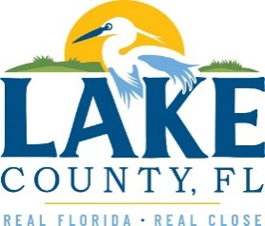
Office of Procurement Services
P.O. Box 7800 • 315 W. Main St., Suite 441 • Tavares, FL 32778
NOTICE OF INTENT TO SOLE SOURCE

PUBLIC NOTICE
This information informs the public and supplier community Lake County intends to enter into a non-competitive agreement to purchase a product/service as research indicates it is available from no other source.
If a qualified supplier can provide the same type of product/service, submit a statement of qualifications, product information and capabilities to the Point of Contact (Section 4.0) by 3:00 P.M. Eastern on Monday, September 25, 2023. Submittals received after this specified time and date will not be considered. Any responses received shall be considered solely for determining whether bona fide competition exists.
- PRODUCT/SERVICE
Provide an online database provider that enables Event Organizers, Sports Facilities, and Destinations to create search engine optimization (SEO) profiles and streamline the ability to search, find, communicate, post events and connect through one seamless platform. Playeasy is the only known platform that provides sports tourism destinations in this manner.
3.0 PROVIDER INFORMATION
Playeasy (Playon, Inc.) is the only known provider offering the described in its entirety.

POINT OF CONTACT
Sandra Rogers, NIGP-CPP, CPPB
Senior Contracting Officer
E-mail: sandra.rogers@lakecountyfl.gov

[The remainder of this page intentionally left blank]

