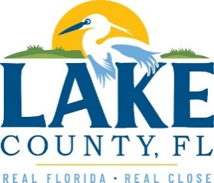
Office of Procurement Services
P.O. Box 7800 • 315 W. Main St., Suite 441 • Tavares, FL 32778
NOTICE OF INTENT TO SOLE SOURCE

PUBLIC NOTICE
This information informs the public and supplier community Lake County intends to enter into a non-competitive agreement to purchase a product/service as research indicates it is available from no other source.
If a qualified supplier can provide the same type of product/service, submit a statement of qualifications, product information and capabilities to the Point of Contact (Section 4.0) by 3:00 P.M. Eastern on February 14, 2023. Submittals received after this specified time and date will not be considered. Any responses received shall be considered solely for determining whether bona fide competition exists.
- PRODUCT/SERVICE
Provide an annual renewal subscription for Handtevy medication management software Mobile (iOS, Android, Windows) to perform real-time verification for high acuity medications, ensure accurate code room documentation, and facilitate downstream notification to clinical teams for pediatric patients.
3.0 PROVIDER INFORMATION
Pediatric Emergency Standards is the only known provider.

POINT OF CONTACT
Sandra Rogers, NIGP-CPP, CPPB
E-mail: sandra.rogers@lakecountyfl.gov

[The remainder of this page intentionally left blank]

