- CONTRACTOR will purchase and maintain at all times during the term of this Contract, without cost or expense to the COUNTY, policies of insurance as indicated below, with a company or companies authorized to do business in the State of Florida, and which are acceptable to the COUNTY, insuring the CONTRACTOR against any and all claims, demands, or causes of action, for injuries received or damage to property relating to the performance of duties, services, or obligations of the CONTRACTOR under the terms and provisions of the Contract. An original certificate of insurance, indicating that CONTRACTOR has coverage in accordance with the requirements of this section must be received and accepted by the COUNTY prior to contract execution or before any work begins. It will be furnished by CONTRACTOR to the COUNTY’S Project Manager and Procurement Services Director within five working days of such request. The parties agree that the policies of insurance and confirming certificates of insurance will insure the CONTRACTOR in accordance with the following minimum limits:

- General Liability insurance on forms no more restrictive than the latest edition of the Occurrence Form Commercial General Liability policy (CG 00 01) of the Insurance Services Office or equivalent without restrictive endorsements, with the following minimum limits and coverage:

Each Occurrence/General Aggregate | $1,000,000/2,000,000
Products-Completed Operations | $2,000,000
Personal & Adv. Injury | $1,000,000
Fire Damage | $50,000
Medical Expense | $5,000
Contractual Liability | Included

- Automobile liability insurance, including owned, non-owned, and hired autos with the minimum Combined Single Limit of $1,000,000

- Workers' compensation insurance based on proper reporting of classification codes and payroll amounts in accordance with Chapter 440, Florida Statutes, and any other applicable law requiring workers' compensation (Federal, maritime, etc.). If not required by law to maintain workers compensation insurance, the CONTRACTOR must provide a notarized statement that if he or she is injured, he or she will not hold the COUNTY responsible for any payment or compensation.

- Employers Liability with the following minimum limits and coverage: Each Accident $1,000,000
Disease-Each Employer $1,000,000
Disease-Policy Limit $1,000,000

- Lake County, a Political Subdivision of the State of Florida, and the Board of County Commissioners, will be named as additional insured as their interest may appear all applicable policies. Certificates of insurance must identify the RFP or ITB number in the Description of Operations section on the Certificate.

- CONTRACTOR must provide a minimum of 30 days prior written notice to the County of any change, cancellation, or nonrenewal of the required insurance.

- Certificates of insurance must evidence a waiver of subrogation in favor of the COUNTY, that coverage must be primary and noncontributory, and that each evidenced policy includes a Cross Liability or Severability of Interests provision, with no requirement of premium by the COUNTY.

- CONTRACTOR must provide a copy of all policy endorsements, reflecting the required coverage, with Lake County listed as an additional insured along with all required provisions to include waiver of subrogation. Contracts cannot be completed without this required insurance documentation. A certificate of insurance (COI) will not be accepted in lieu of the policy endorsements.

- Certificate holder must be:
LAKE COUNTY, A POLITICAL SUBDIVISION OF THE STATE OF FLORIDA, AND THE BOARD OF COUNTY COMMISSIONERS.
P.O. BOX 7800 TAVARES, FL 32778-7800

- All self-insured retentions will appear on the certificates and will be subject to approval by the COUNTY. At the option of the COUNTY, the insurer will reduce or eliminate such self- insured retentions; or CONTRACTOR will be required to procure a bond guaranteeing payment of losses and related claims expenses.

- The COUNTY will be exempt from, and in no way liable for, any sums of money, which may represent a deductible or self-insured retention in any insurance policy. The payment of such deductible or self-insured retention will be the sole responsibility of the CONTRACTOR or subcontractor providing such insurance.

- CONTRACTOR will be responsible for subcontractors and their insurance. Subcontractors are to provide Certificates of Insurance to the COUNTY evidencing coverage and terms in accordance with the CONTRACTOR’S requirements.

- Failure to obtain and maintain such insurance as set out above will be considered a breach of contract and may result in termination of the contract for default.

- Neither approval by the COUNTY of any insurance supplied by CONTRACTOR, nor a failure to disapprove that insurance, will relieve CONTRACTOR of full responsibility of liability, damages, and accidents as set forth herein.

[The remainder of this page is intentionally left blank.]

SAMPLE CERTIFICATE OF INSURANCE
Construction Contracts
HIGH LIMITS

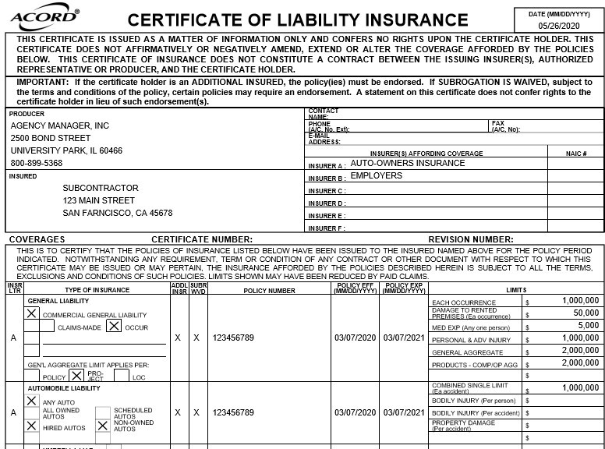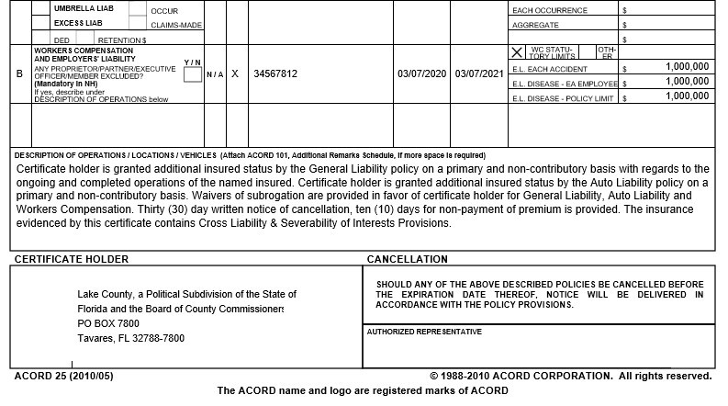Date Certificate Produced

Subcontractor's Insurance Broker

Agency Contact Information

Named Insured (This should match the subcontractor name listed on the contract)

Minimum required coverage limits

"Claims Made" or "Modified Occurrence" is not acceptable

Auto Liability must be written on an "any auto" basis, including hired/non-owned

This section must reference the job number & project name. Description should read as shown here

Certificate holder should read exactly as shown here

Must be signed by agent

**PLEASE REFER TO YOUR CONTRACT TO VERIFY COMPLIANCE WITH ALL REQUIREMENTS**

