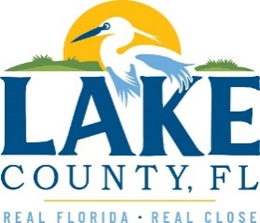
Office of Procurement Services
P.O. Box 7800 • 315 W. Main St., Suite 441 • Tavares, FL 32778
SOLICTATION: Lake County Health Administration Building Asbestos Abatement Services 07/27/2022

Vendors are responsible for the receipt and acknowledgement of all addenda to a solicitation. Confirm acknowledgement by including an electronically completed copy of this addendum with submittal. Failure to acknowledge each addendum may prevent the submittal from being considered for award.
THE DATE FOR RECEIPT OF PROPOSALS WAS CHANGED IN ADDENDUM 2 TO
AUGUST 3, 2022, AT 3:00PM (EST)

QUESTIONS/RESPONSES
- In the IT equipment room there are computers and racks. Are these being removed by the County prior to the abatement?
Response: Yes. County IT will need to remove.
- In this same room there is a plywood board with IT equipment attached.
Response: County IT will remove equipment. Contractor shall remove and reinstall plywood.
- Will the County remove the equipment and board in this room and anywhere else this condition exists in the building?
Response: IT will remove equipment. Contractor shall remove and reinstall plywood.

ACKNOWLEDGEMENT

Firm Name: Click or tap here to enter text.
I hereby certify that my electronic signature has the same legal effect as if made under oath; that I am an authorized representative of this vendor and/or empowered to execute this submittal on behalf of the vendor.
Signature of Legal Representative Submitting this Bid: Click or tap here to enter text.
Date: Click or tap to enter a date.
Print Name: Click or tap here to enter text.
Title: Click or tap here to enter text.
Primary E-mail Address: Click or tap here to enter text.
Secondary E-mail Address: Click or tap here to enter text.

