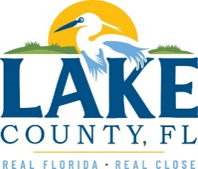
Office of Procurement Services
P.O. Box 7800 • 315 W. Main St., Suite 441 • Tavares, FL 32778
06/24/2022

SOLICTATION: Lake County Health Administration Building Asbestos Abatement Services
Vendors are responsible for the receipt and acknowledgement of all addenda to a solicitation. Confirm acknowledgement by including an electronically completed copy of this addendum with submittal. Failure to acknowledge each addendum may prevent the submittal from being considered for award.
THIS ADDENDUM DOES NOT CHANGE THE DATE FOR RECEIPT OF PROPOSALS.
INFORMATION
The location of the non-mandatory pre-bid conference on Thursday June 30, 2022, at 3:00PM has been changed to: 16140 U.S. Highway 441 Eustis, Florida (Lake County Health Administration Building).

ACKNOWLEDGEMENT

Firm Name: Click or tap here to enter text.
I hereby certify that my electronic signature has the same legal effect as if made under oath; that I am an authorized representative of this vendor and/or empowered to execute this submittal on behalf of the vendor.
Signature of Legal Representative Submitting this Bid: Click or tap here to enter text.
Date: Click or tap to enter a date.
Print Name: Click or tap here to enter text.
Title: Click or tap here to enter text.
Primary E-mail Address: Click or tap here to enter text.
Secondary E-mail Address: Click or tap here to enter text.

