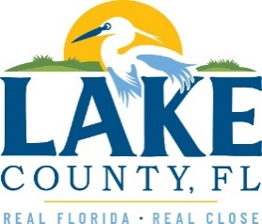
Office of Procurement Services
P.O. Box 7800 • 315 W. Main St., Suite 441 • Tavares, FL 32778
SOLICTATION: On-Call Geo-Technical Engineering Services 05/26/2022

Vendors are responsible for the receipt and acknowledgement of all addenda to a solicitation. Confirm acknowledgement by including an electronically completed copy of this addendum with submittal. Failure to acknowledge each addendum may prevent the submittal from being considered for award.
THIS ADDENDUM DOES NOT CHANGE THE DATE FOR RECEIPT OF PROPOSALS.
QUESTIONS/RESPONSES
Q1. Please provide the winning proposals for 18-0208 On-Call Geotechnical Engineering Services Contract awarded 6/25/2018.
R1. The three proposals can be reviewed by clicking on this share drive link: Sharepoint Procurement 18-0208 On-Call GeoTechnical Engineering Services

ACKNOWLEDGEMENT

Firm Name: Click or tap here to enter text.
I hereby certify that my electronic signature has the same legal effect as if made under oath; that I am an authorized representative of this vendor and/or empowered to execute this submittal on behalf of the vendor.
Signature of Legal Representative Submitting this Bid: Click or tap here to enter text.
Date: Click or tap to enter a date.
Print Name: Click or tap here to enter text.
Title: Click or tap here to enter text.
Primary E-mail Address: Click or tap here to enter text.
Secondary E-mail Address: Click or tap here to enter text.

