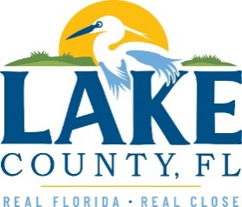
Office of Procurement Services
P.O. Box 7800 • 315 W. Main St., Suite 441 • Tavares, FL 32778
SOLICTATION: Construction of Fire Station 71 06/17/2022

Vendors are responsible for the receipt and acknowledgement of all addenda to a solicitation. Confirm acknowledgement by including an electronically completed copy of this addendum with submittal. Failure to acknowledge each addendum may prevent the submittal from being considered for award.
THIS ADDENDUM CHANGES THE DATE FOR RECEIPT OF PROPOSALS TO:
JULY 21, 2022 @ 3:00PM (EST).
QUESTIONS/RESPONSES
- Can you advise if all the signs are supplied by the owner?
Response: The two Fire Station 71 signs attached to the facade of the building are owner-furnished items.
- How does the county handle supply chain delays?
Response: Contractors should consider supply chain delays in quoted items and integrate estimated arrival times into their time estimates.
- Will the county pay deposits to lock in pricing?
Response: Pay applications may be submitted for stored materials. No deposits will be paid.
- Will the county pay for offsite stored materials?
Response: Materials storage should be included in the base price.

ACKNOWLEDGEMENT

Firm Name: Click or tap here to enter text.
I hereby certify that my electronic signature has the same legal effect as if made under oath; that I am an authorized representative of this vendor and/or empowered to execute this submittal on behalf of the vendor.
Signature of Legal Representative Submitting this Bid: Click or tap here to enter text.
Date: Click or tap to enter a date.
Print Name: Click or tap here to enter text.
Title: Click or tap here to enter text.
Primary E-mail Address: Click or tap here to enter text.
Secondary E-mail Address: Click or tap here to enter text.

