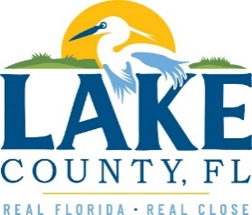
Office of Procurement Services
P.O. Box 7800 • 315 W. Main St., Suite 416 • Tavares, FL 32778

SOLICTATION: Closure of Lake County Landfill Cell Phase III 08/31/2022

Vendors are responsible for the receipt and acknowledgement of all addenda to a solicitation. Confirm acknowledgement by including an electronically completed copy of this addendum with submittal. Failure to acknowledge each addendum may prevent the submittal from being considered for award.
THIS ADDENDUM CHANGES THE DATE FOR RECEIPT OF PROPOSALS FROM 09/07/2022 TO 09/28/2022 TO ALLOW THE COUNTY TO REVIEW ALL QUESTIONS SUBMITTED.

ACKNOWLEDGEMENT

Firm Name: Click or tap here to enter text.
I hereby certify that my electronic signature has the same legal effect as if made under oath; that I am an authorized representative of this vendor and/or empowered to execute this submittal on behalf of the vendor.
Signature of Legal Representative Submitting this Bid: Click or tap here to enter text.
Date: Click or tap to enter a date.
Print Name: Click or tap here to enter text.
Title: Click or tap here to enter text.
Primary E-mail Address: Click or tap here to enter text.
Secondary E-mail Address: Click or tap here to enter text.

