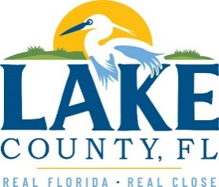
Office of Procurement Services
P.O. Box 7800 • 315 W. Main St., Suite 441 • Tavares, FL 32778
SOLICTATION: Building Automation System Replacement at the CAB 10/19/2022

Vendors are responsible for the receipt and acknowledgement of all addenda to a solicitation. Confirm acknowledgement by including an electronically completed copy of this addendum with submittal. Failure to acknowledge each addendum may prevent the submittal from being considered for award.
- This addendum changes the date of receipt of proposal from 10/26/2022 to 11/30/2022.
- The last day to ask questions has been changed from 10/05/2022 to 11/09/2022.

ACKNOWLEDGEMENT

Firm Name: Click or tap here to enter text.
I hereby certify that my electronic signature has the same legal effect as if made under oath; that I am an authorized representative of this vendor and/or empowered to execute this submittal on behalf of the vendor.
Signature of Legal Representative Submitting this Bid: Click or tap here to enter text.
Date: Click or tap to enter a date.
Print Name: Click or tap here to enter text.
Title: Click or tap here to enter text.
Primary E-mail Address: Click or tap here to enter text.
Secondary E-mail Address: Click or tap here to enter text.

